**Prior Instructions**

* **Please do read all the questions before performing any operations in the database**
* **Once you have fully gone through the questions then likewise decide the contents and table columns and follow the below instructions**

1. Create Student Database

create database student;

use student;

1. Create the following table under the Student Database:
   1. StudentBasicInformation
      1. Columns
         1. StudentName
         2. StudentSurname
         3. StudentRollNo
         4. StudentAddress
         5. Add more three basic columns of the name of your own

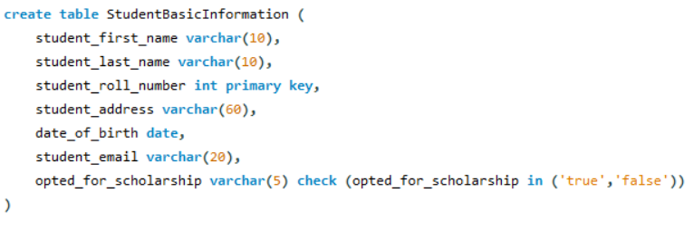

* 1. StudentAdmissionPaymentDetails
     1. Columns
        1. StudentRollNo
        2. AmountPaid
        3. AmountBalance
        4. Add more four basic columns of the name of your own

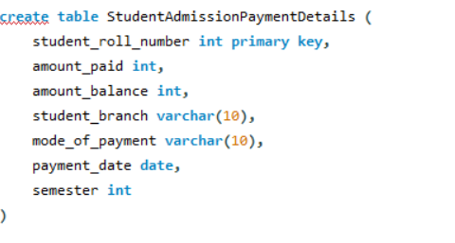

* 1. StudentSubjectInformation
     1. Columns
        1. SubjectOpted
        2. StudentRollNo
        3. SubjectTotalMarks
        4. SubjectObtainedMarks
        5. StudentMarksPercentage
        6. Add more one columns of the name of your own

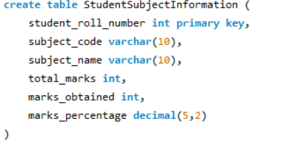

* 1. SubjectScholarshipInformation
     1. Columns
        1. StudentRollNo
        2. ScholarshipName
        3. ScholarshipDescription
        4. ScholarshipAmount
        5. ScholarshipCategory
        6. Add more two columns of the name of your own

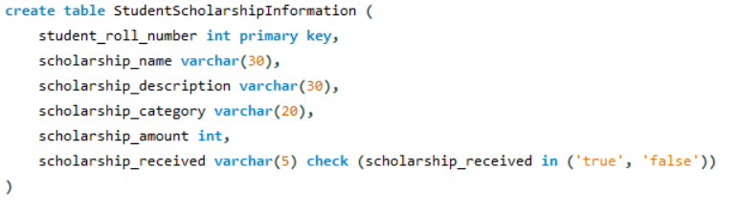

1. Insert more than 10 records in each and every table created

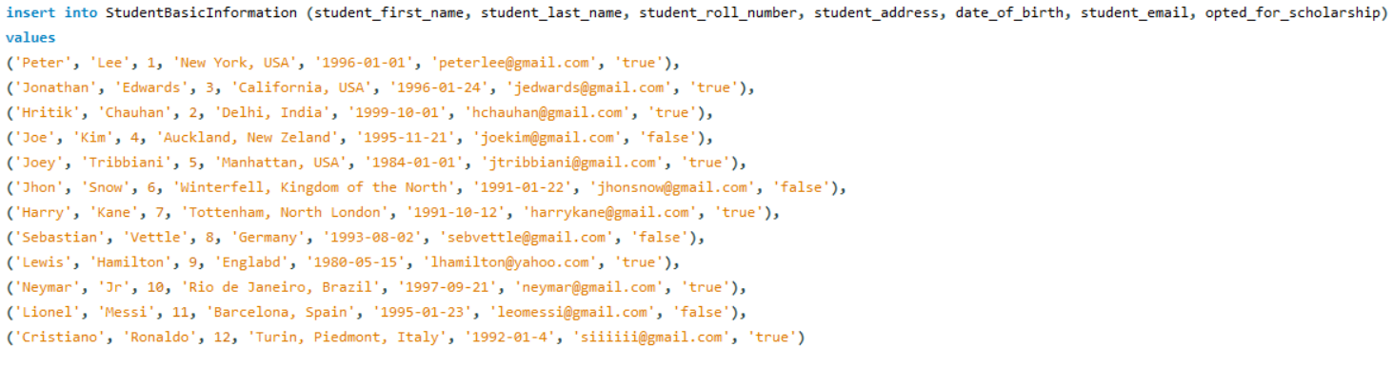

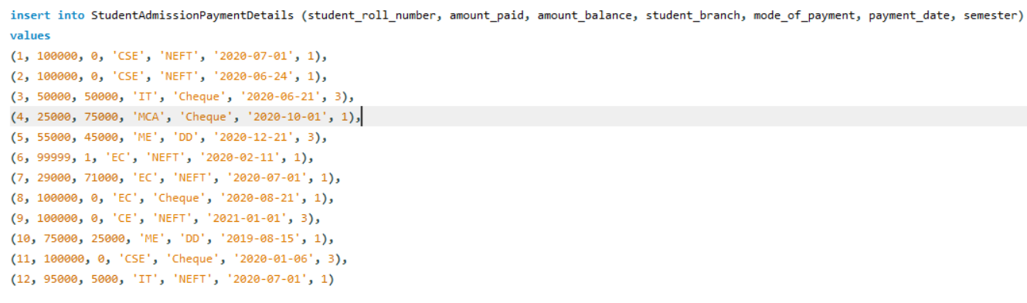

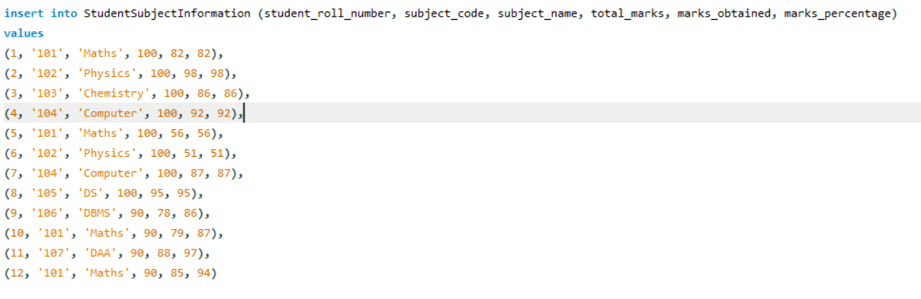

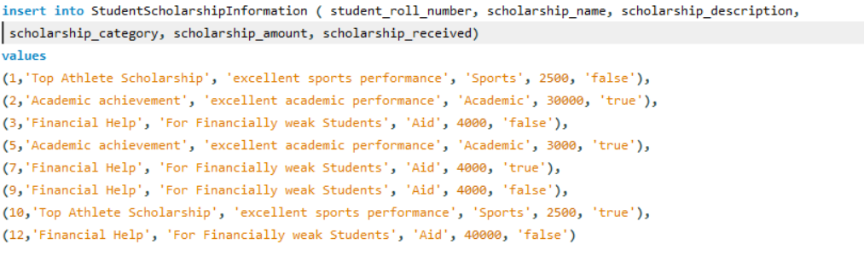

1. Snap of the all the tables once the insertion is completed

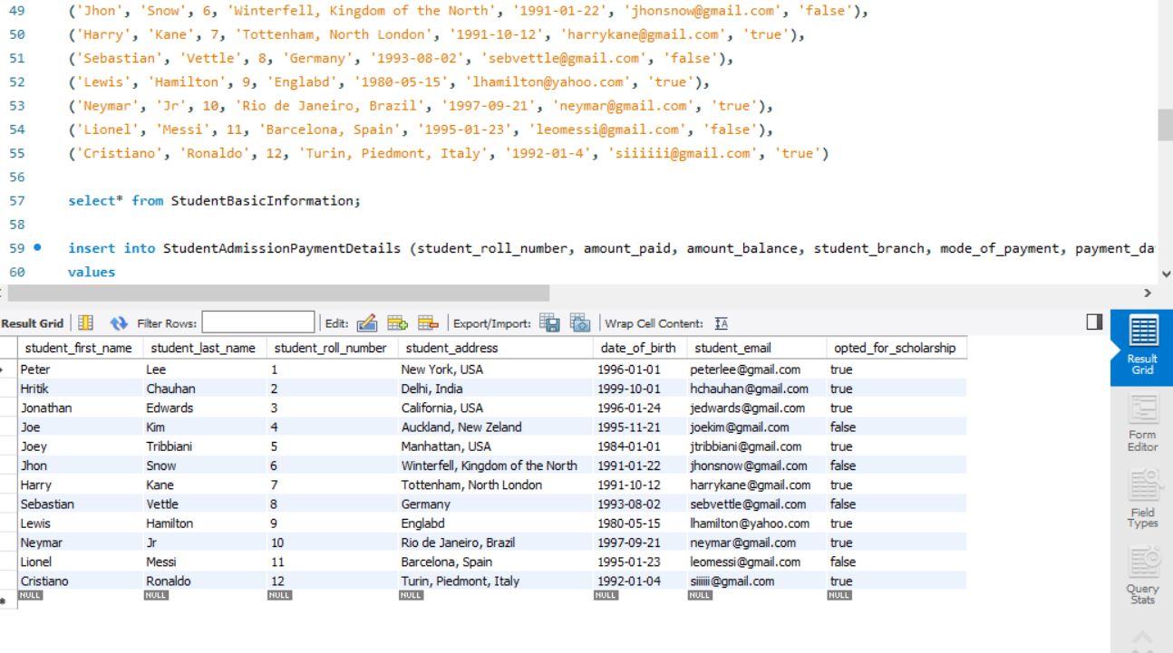

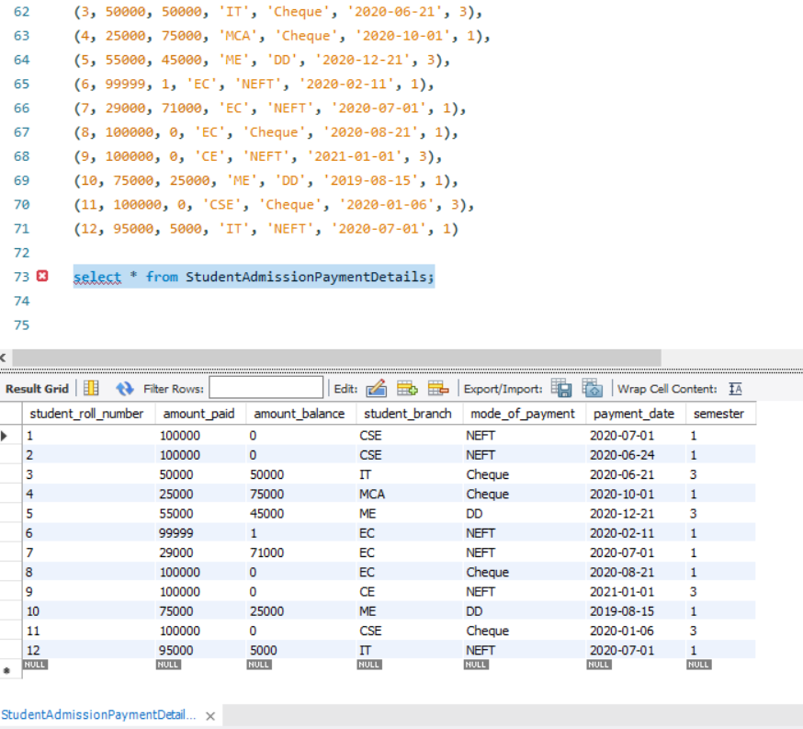

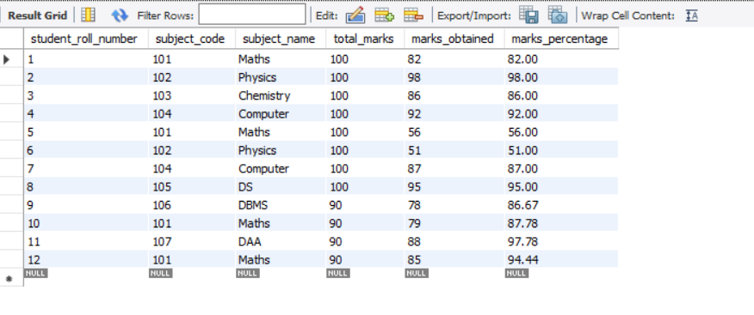

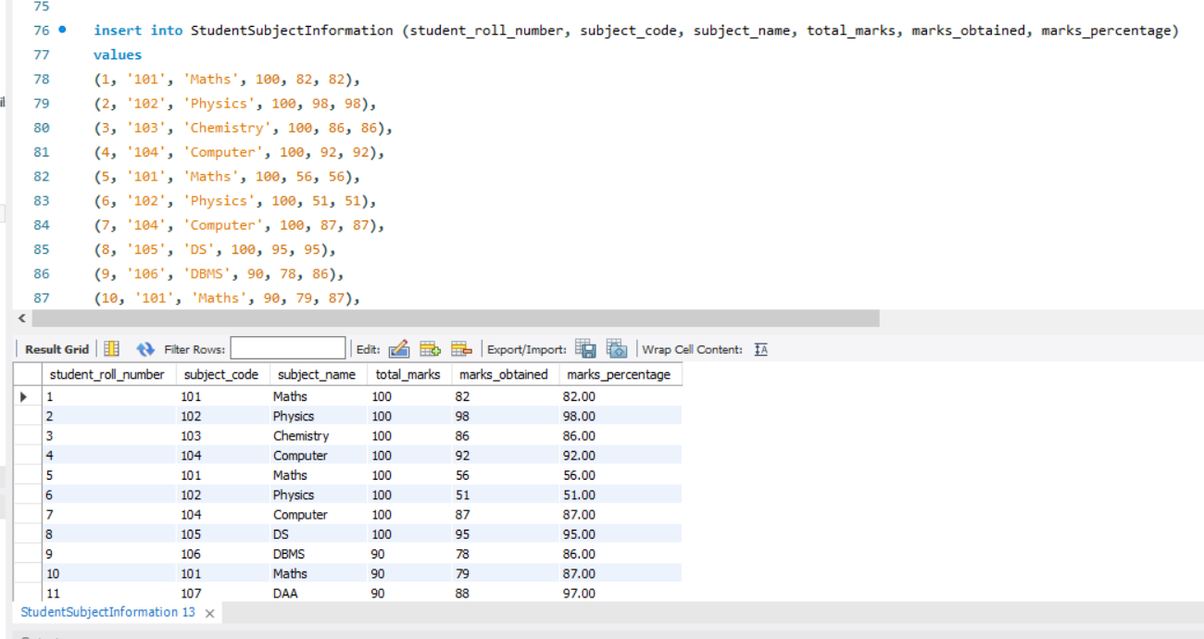

1. Update any 5 records of your choice in any table like update the StudentAddress with some other address content and likewise so on with any records of any table of your choice

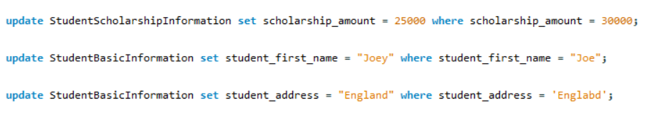

1. Snap of the all the tables post updation

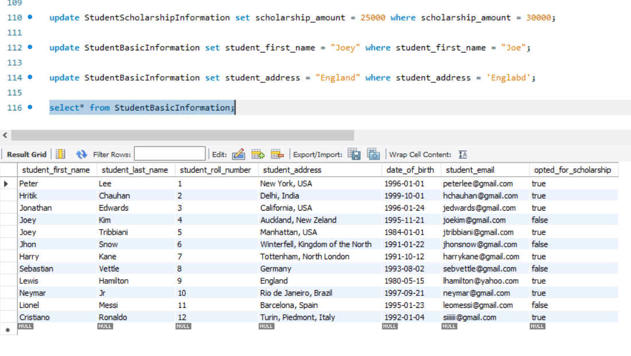

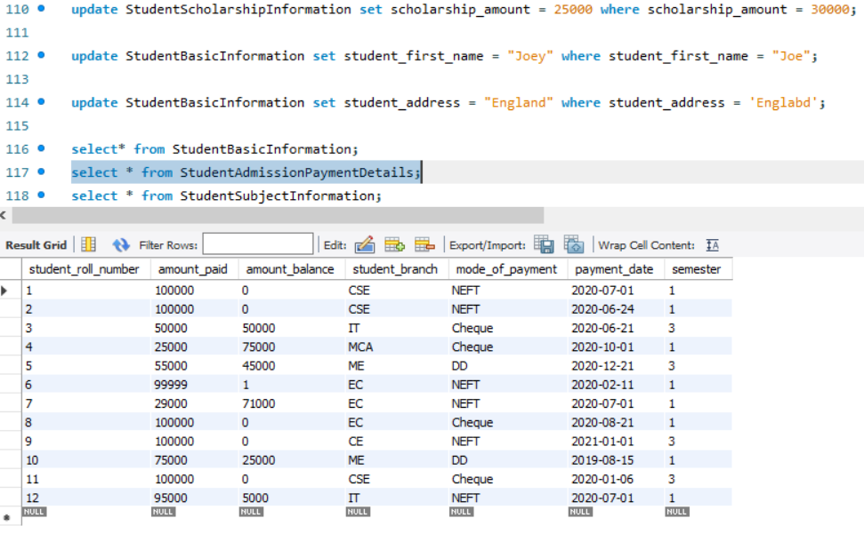

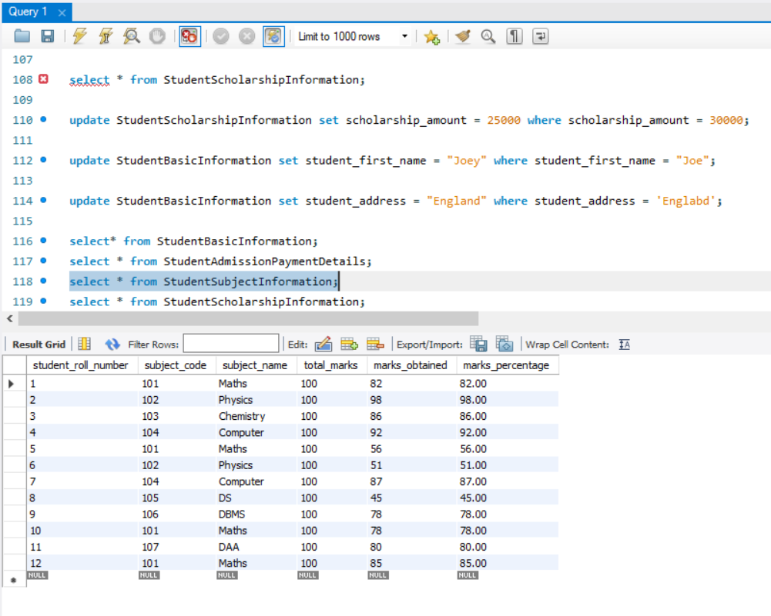

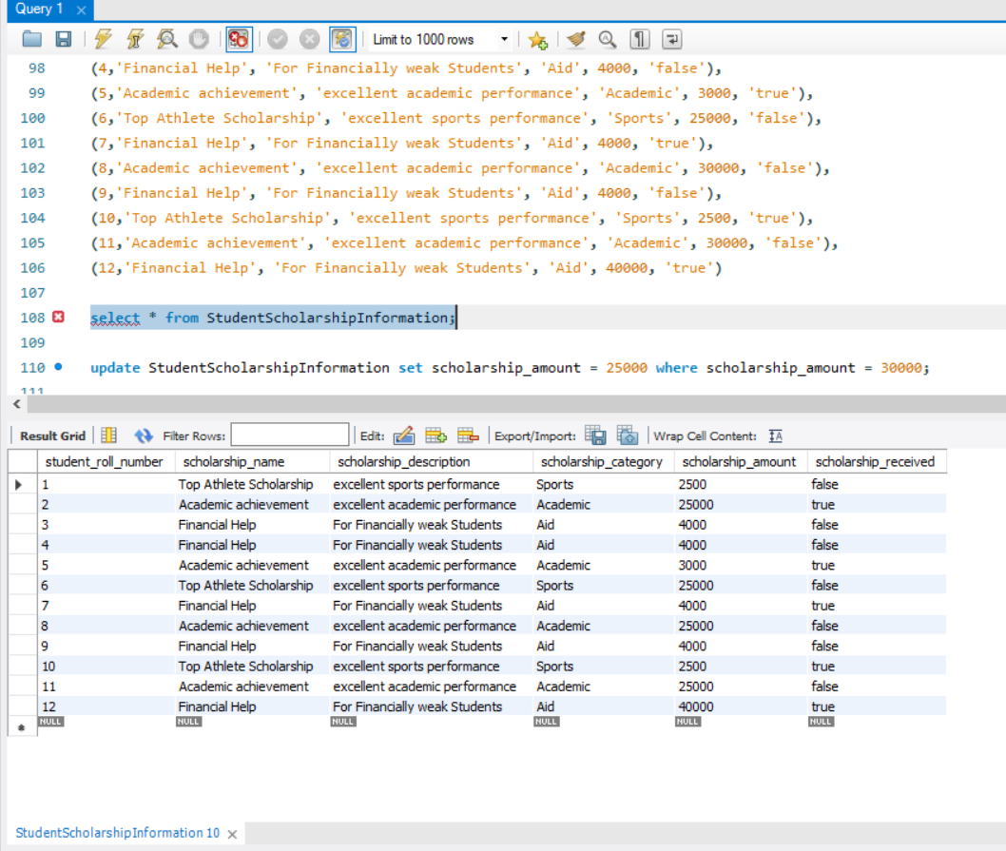

1. Select the student details records who has received the scholarship more than 5000Rs/-

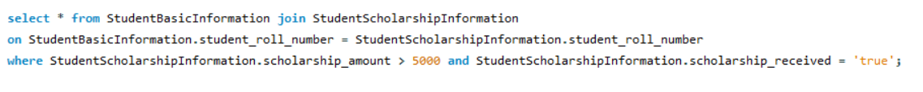

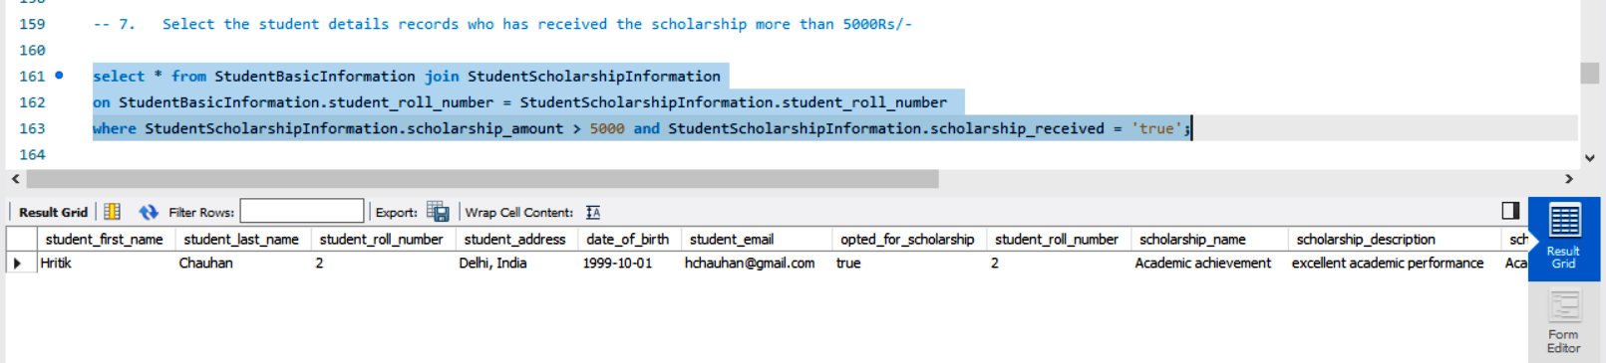

1. Select the students who opted for scholarship but has not got the scholarship

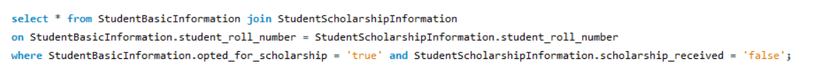

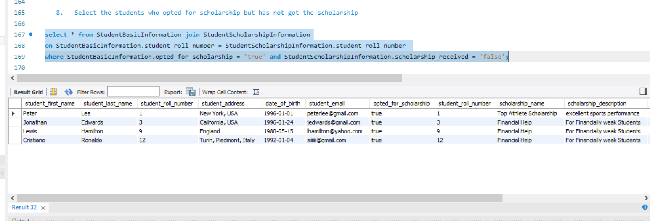

1. Fill in data for the percentage column i.e. StudentMarksPercentage in the table StudentSubjectInformation by creating and using the stored procedure created

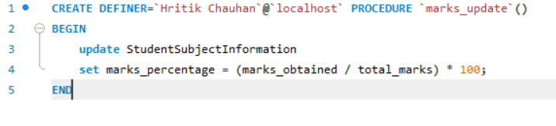

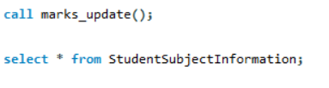

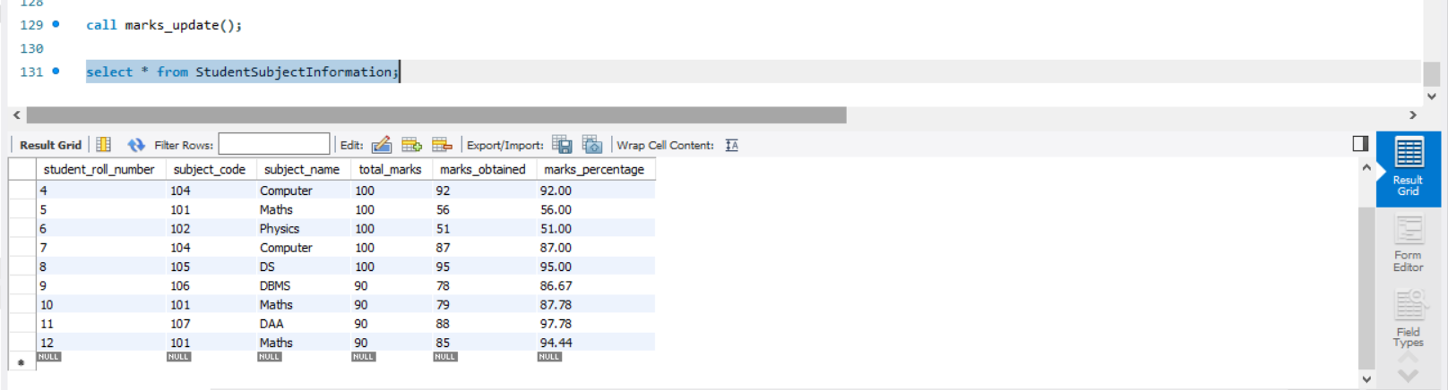

1. Decide the category of the scholarship depending upon the marks/percentage obtained by the student and likewise update the ScholarshipCategory column, create a stored procedure in order to handle this operation

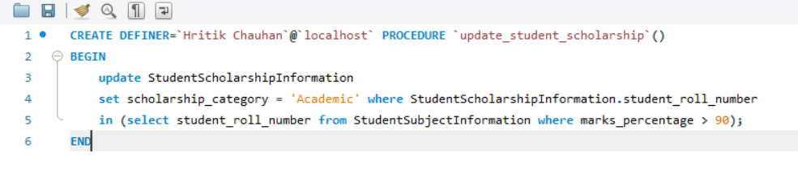

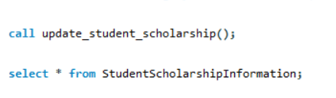

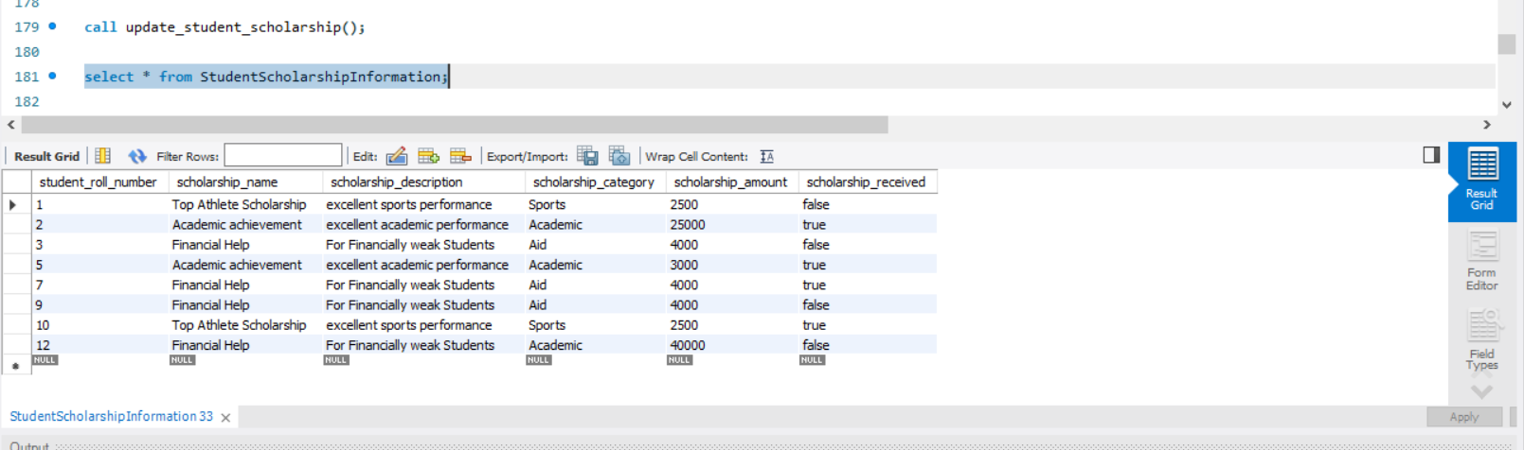

1. Create the View which shows balance amount to be paid by the student along with the student detailed information (use join)

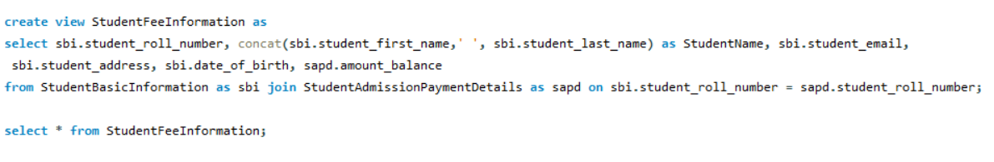

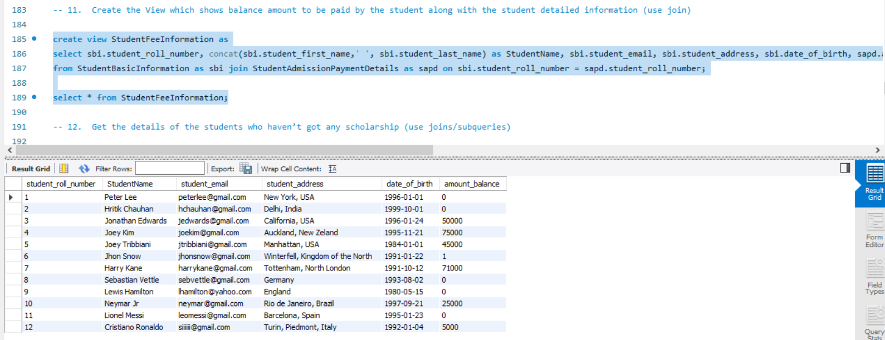

1. Get the details of the students who haven’t got any scholarship (use joins/subqueries)

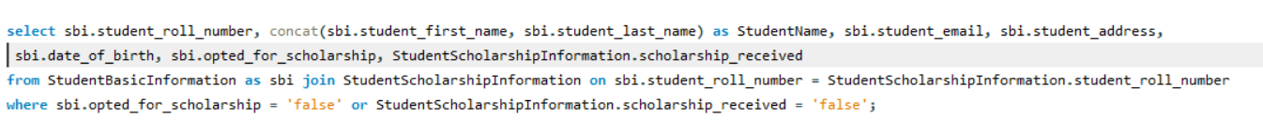

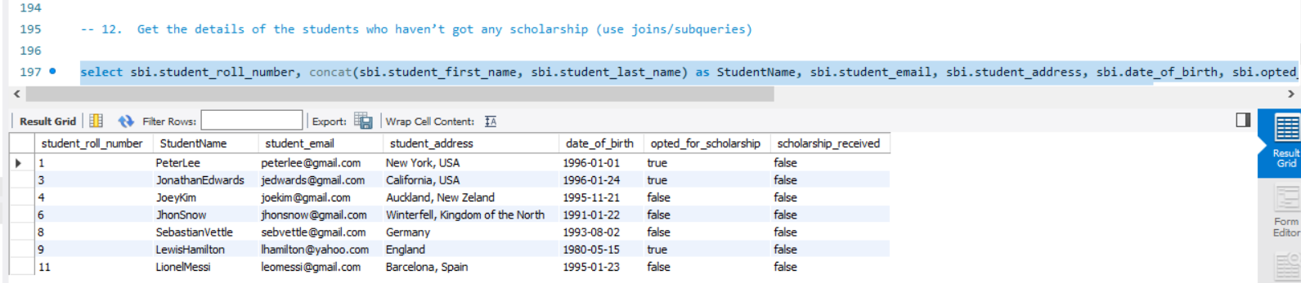

1. Create Stored Procedure which will be return the amount balance to be paid by the student as per the student roll number passed through the stored procedure as the input

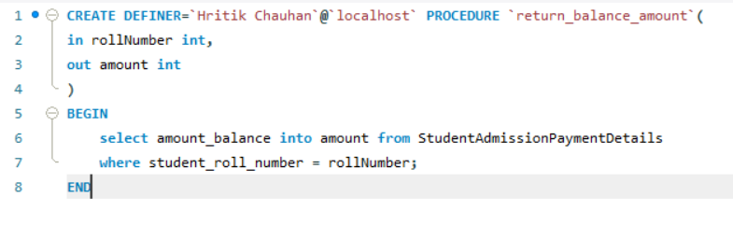

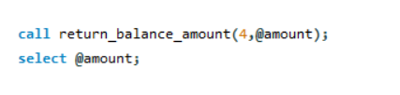

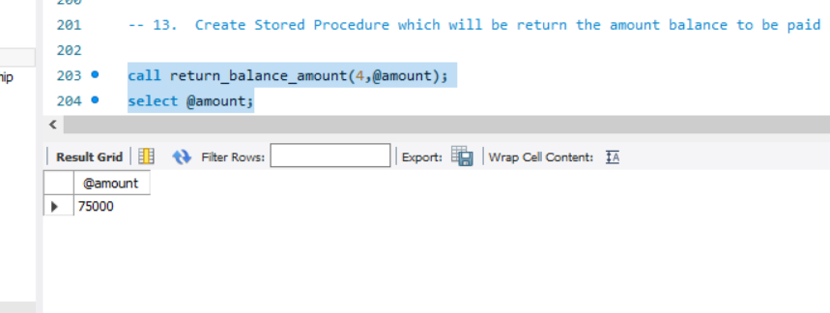

1. Retrieve the top five student details as per the StudentMarksPercentage values (use subqueries)

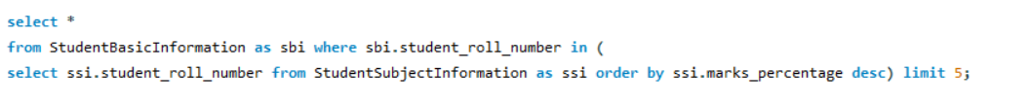

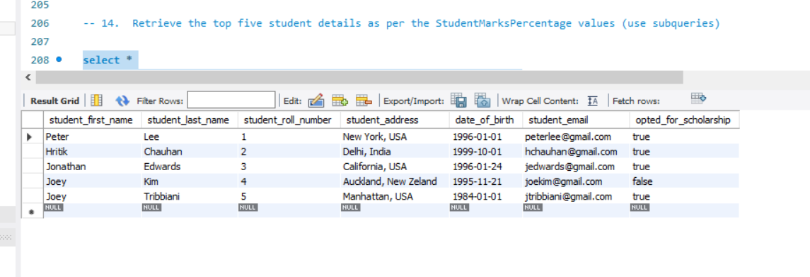

1. Try to use all the three types of join learned today in a relevant way, and explain the same why you thought of using that particular join for your selected scenarios (try to cover relevant and real time scenarios for all the three studied joins)

Inner Jon to Select the information of the student who have secured 90% or more

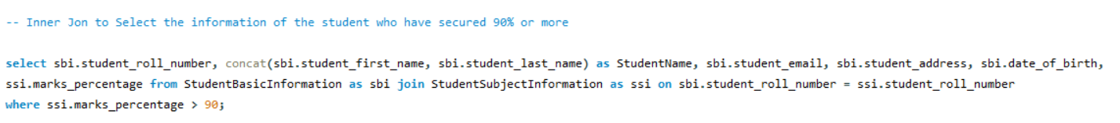

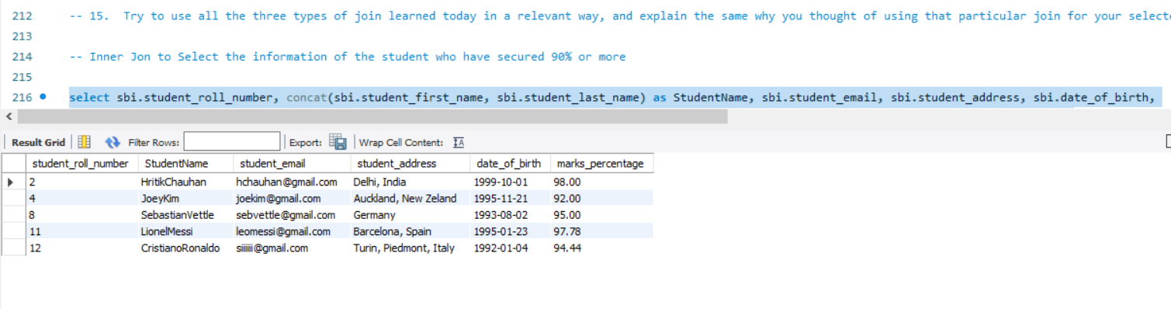

Left Outer Join to select scholarship information for all the students even if they have never applied for any scholarship or not

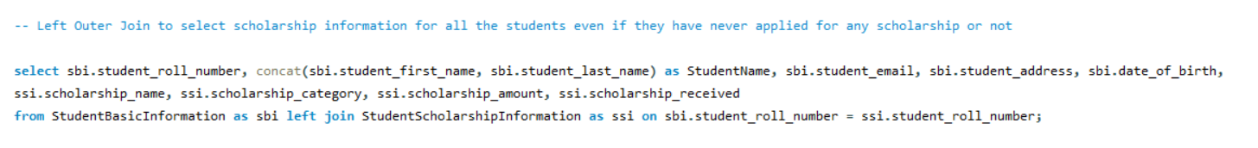

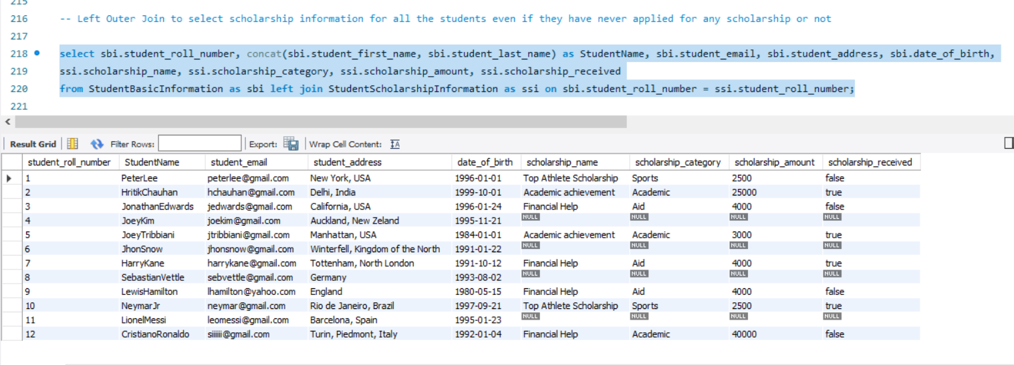

1. Mention the differences between the delete, drop and truncate commands

Delete Operation

It is a DML command. It is use to delete the one or more tuples of a table. With the help of “DELETE” command we can either delete all the rows in one go or can delete row one by one. i.e., we can use it as per the requirement or the condition using Where clause. It is comparatively slower than TRUNCATE cmd.

Truncate Operation

It is a DDL command. It is use to delete all the rows of a relation (table) in one go. With the help of “TRUNCATE” command we can’t delete the single row as here WHERE clause is not used.

Drop Operation

It is a DDL command. It is use to drop the whole table. With the help of “DROP” command we can drop (delete) the whole structure in one go i.e. it removes the named elements of the schema. By using this command the existence of the whole table is finished or say lost.

1. Get the count of the Scholarship category which is highly been availed by the students, i.e. get the count of the total number of students corresponding to the each scholarships category

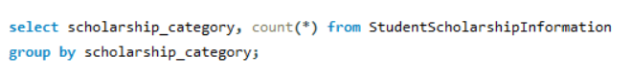

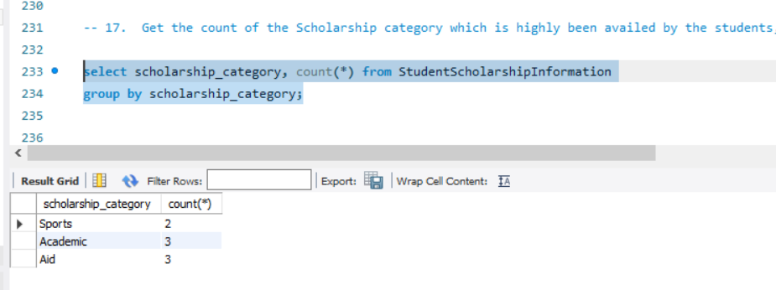

1. Along with the assignment no. 17 try to retrieve the maximum used scholarship category



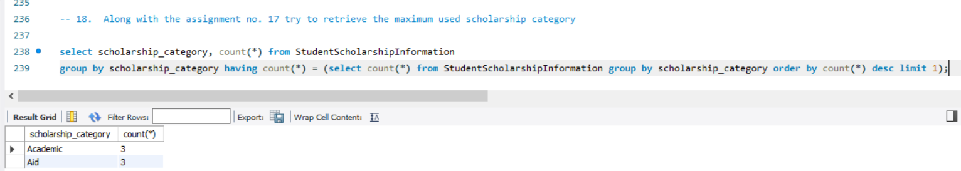

1. Retrieve the percentage of the students along with students detailed information who has scored the highest percentage along with availing the maximum scholarship amount

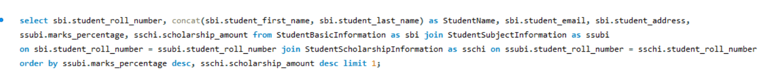

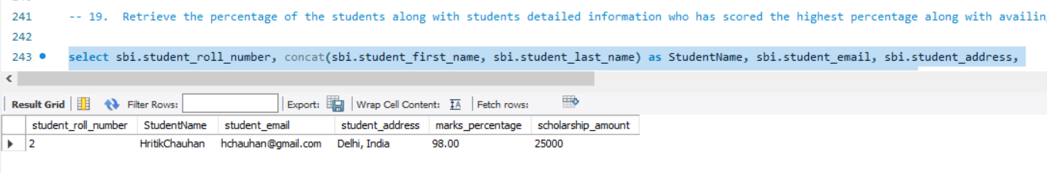

1. Difference between the Triggers, Stored Procedures, Views and Functions

Triggers

A trigger is a procedural code that is automatically executed in response to certain events on a specified table.

Stored Procedures

Stored Procedures are created to perform one or more DML operations on Database. It is a group of SQL statements that accepts some input in the form of parameters and performs some task and may or may not returns a value.

Stored procedures are pre-compiled objects which are compiled for the first time and its compiled format is saved. It will execute whenever it is called.

Views

Views in SQL are kind of virtual tables. A view also has rows and columns as they are in a real table in the database. We can create a view by selecting fields from one or more tables present in the database. A View can either have all the rows of a table or specific rows based on certain condition.

Functions

A function is compiled and executed every time whenever it is called. A function must return a value and cannot modify the data received as parameters.